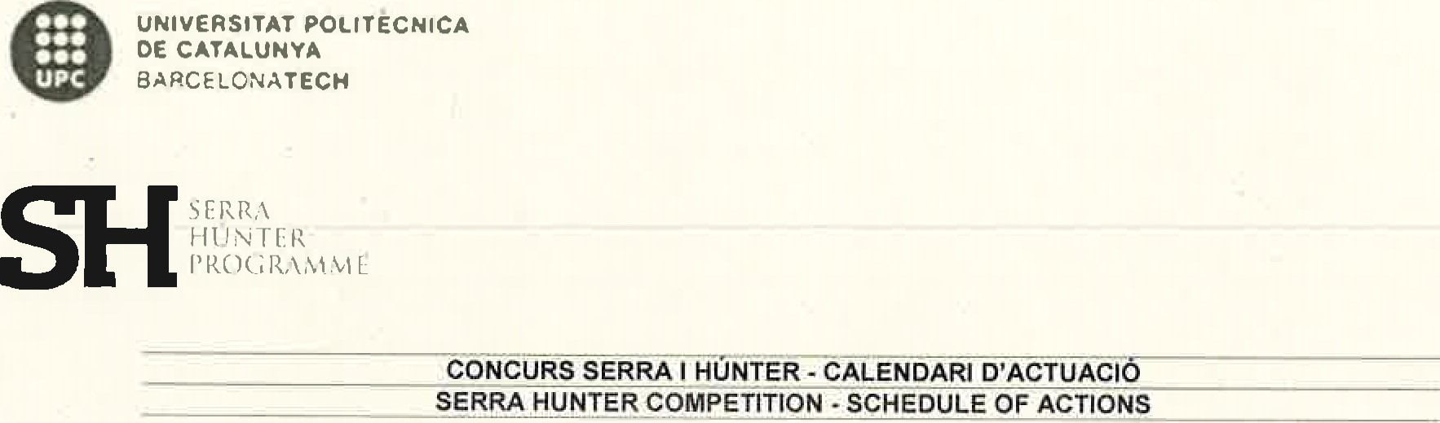
Referéncia
del concurs  Com etition reference | UPC-LE-221-017

Es convoca els candidats i candidates que han superat l'anålisi i avaluaciö dels merits
Publicaciö al DOGC | Cate oria | perfil
Publication DOGC | Cate ory | Profile
07/03/2023 | Professorat Lector  Tenure-eli ible lecturer | Computational engineering Serra Hünter Programme
La prova de selecciö sera püblica, el candidat o candidata haurå de fer, durant un måxim d'una hora i mitja, una breu presentaciö personal i, seguidament, un seminari sobre el tema que consideri adient. A continuaciö, la comissiö formularå les qüestions que consideri oportunes, tant sobre els merits aportats en el seu curriculum com sobre el seminari impartit o sobre qualsevol altre aspecte relacionat amb el contracte Ofert i l'activitat que es preveu que haurå de desenvolupar. Aquesta prova es podrå fer en Ilengua anglesa.
El candidat o candidata que no es presenti a l'hora assenyalada, disposarå d'una segona convocatöria al cap de 15 minuts. Si no s'hi presenta, es considerarå no presentat i, per tant, serå exclös del procés de selecciö.

The candidates who have passed the analysis and assessment of merits are notified.
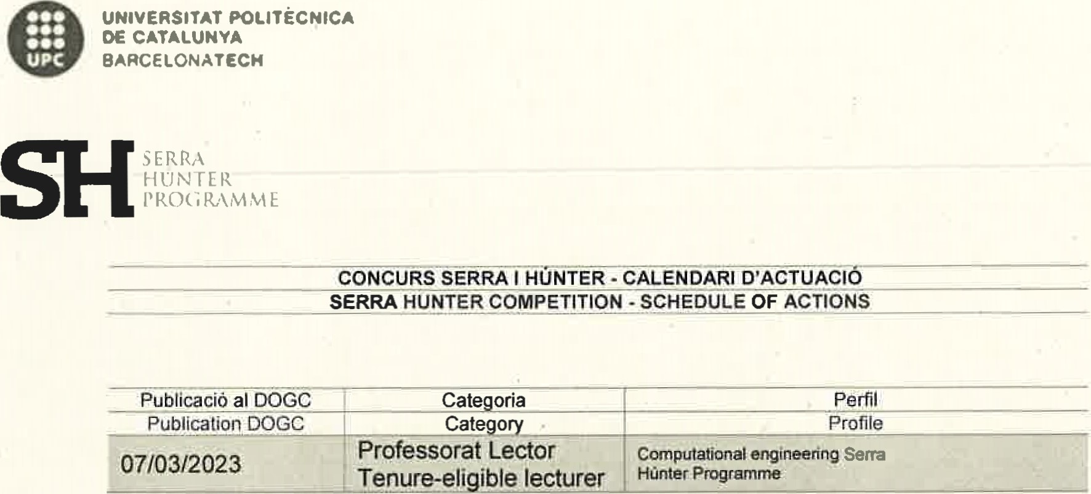
The selection test will be public. The candidates must make a brief personal presentation followed by a seminar on a topic of the candidate's choosing, together lasting an hour and a half at most. The committee will then ask any questions that it deems appropriate on the merits presented in the CVI the seminar given or any other aspect related to the contract offered and the activities that successful candidates will be expected to carry out. The test may be conducted in English
Candidates who fail to show at the set time are called for the second time 15 minutes later. Candidates who fail to show will be considered absent and therefore excluded from the selection process.

Referéncia del concurs reference | UPC-LE-221-017
Com etition

ACORDS AGREEMENTS
The SelectionCommittee agrees that the test will have the following structure: Short presentatjon (30 minutes) about the research lines. teaching interest and motivation of the candidate
Short teaching session (15 minutes) based on Computational Engineering fundamentals. This would be a summary ofan extended session to be taught in any bachelor introductory course to Computational Engineering. (see details*t)• Discussion between the candidate and the Selection Committee (15 minutes)
As part orthe recruitment pos*$$ the Serra Hunter. candidates must conduct a 15•mjnute prob. teacrtmggeseon. The purpose session is to Ä1d.idates an opportunity to showcase their teaching abiliti€5 and demons*rate their approach to Instruction.
Teaching subfect candidates topics Of your choice; suchas the finite etenent memod for partial differential equations (PDE5) etc wtt.hjn the field of computational enotneenng.
Audience: The audience for probe teachiing consist of undergraduate student who alre•åy possess a foundation know•jedge in linear aigeöra, which essential prerequisites for We encourage candidates to effectivey communicate tte ftÜidamentul conceptsot the chosen topie ensuring that their teaching methodology jntegrated seamlessty into the session
Criterion: this probe teaching *5Sion serves as an impottant evaluation of candidate's ability to engage students. effectively convey complex ideas, 3nd create an inclusive teaming environment We took torwar< to 'Mtnessing carutidatez teaching techniques and their ability to inspire and educate our futum engineers scientists
Referéncia del concurs Com etition reference | UPC-LE-221-017
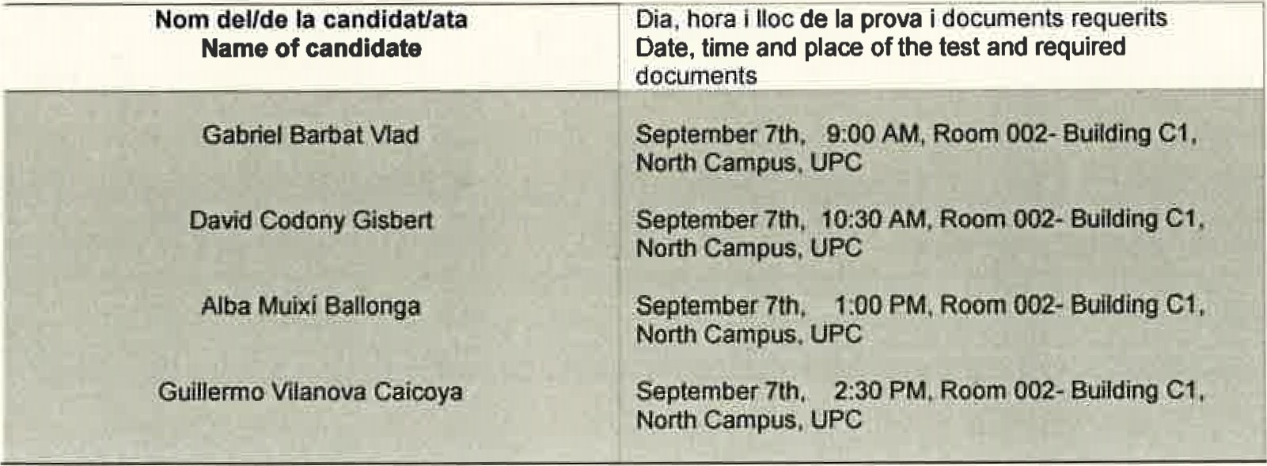
Publicaciå al DOGC Publication DOGC | Cate oria | Perfit
 | Cate o | Profile
07/03/2023 | Professorat Lector  Tenure-eli ible lecturer | Computational engineering Serra Hünter Programme
Barcelona, 3rd of July 2023

